|  |  |  |
| --- | --- | --- |
| Sigla albastra final 1 | **„VASILE ALECSANDRI” University of BACAU** Faculty of EngineeringCalea Marasesti, No. 157, 600115, Bacau, Phone/Fax +40 234 580170 [**http://www.ub.ro/inginerie/**](http://www.ub.ro/inginerie/)**; e-mail:** [**decaning@ub.ro**](mailto:decaning@ub.ro) |  |

**This certificate is awarded to**

**…POPPESCU POPESCU…**

for serving as a reviewer/editorial board member

for

**Journal of Engineering Studies and Research**

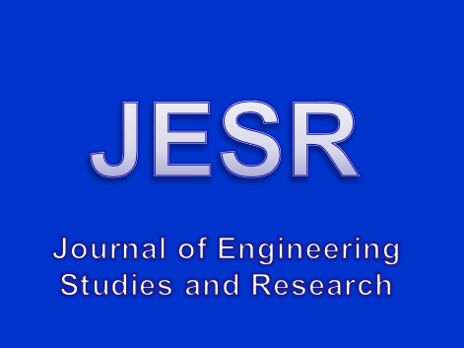

**ISSN Online: 2344-4932**

**ISSN Print: 2068-7559**

**https://jesr.ub.ro/**

**Date EDITOR-IN-CHIEF**

**Valentin Nedeff**